Greyt Expectations Greyhound Rescue
Exquisite Giuseppe Armani Sculpture
"Running Free"
Raffle
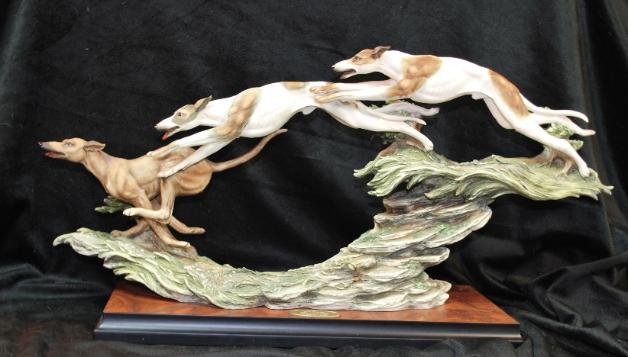
This is a limited-edition sculpture. It is in excellent condition in the original box with a certificate of authenticity. It is 12 inches high and 24 inches long. You can find it online valued at $1000 or more.
$10 for 1 ticket
$25 for 3 tickets
The lucky ticket will be drawn 11/25/2018
Cash/Check/Paypal

If you would like to purchase raffle tickets, please fill out this form, make your check payable to GEGR and mail it back to:

GEGR
12540 Blunts Cove Drive
Lusby, MD 20657
e-mail submissions with payment via Paypal can be sent to
Info@greytexpectations.org
Name: ________________________________
Address_________________________ City_______________ State___
Zip_______ Email Address: ____________________
Phone: ____________________
Number of Tickets: ________________
Form of Payment: ___Cash ___Check ___Paypal (please add $2.00 to help cover fees if you are paying from a Paypal account)

Once your payment is received, your ticket number(s) will be e-mailed to you. You do not need to be present to win. Winner can pick it up or we can arrange for it to be professionally packed and shipped. Thank you so much!!

